INVITATION

We are happy to welcome scientists, engineers and students at our international event for exchanging information on AEROGELS: synthesis, characterisation, and applications in
various fields.

-------------------------------------------------

SCOPE

AEROGELS are fascinating materials obtained by combination of sol-gel technology and (mainly) supercritical drying. As aerogels are solids with very high nano-porosity, they exhibit unique properties and are currently subjected to a worldwide development with applications in many fields (insulation in buildings, oil/gas wells and pipes, aerospace – adsorbents or catalysts – capacitances – optics – drug delivery systems, etc.). We encourage scientific contribution covering all topics of aerogel-related science and technology

-------------------------------------------------

DEADLINES

Abstract: 15. June, 2020

Registration: 09. September 2020

ABSTRACTS

An abstract (less than 300 words) should be sent before 15. June, 2020

aerogelconference@tuhh.de

When submitting the abstract, please state if you prefer to present your paper as an oral or a poster.

-------------------------------------------------

REGISTRATION

The proceedings will be available online

LOCATION

ONLINE conference

16.-18. September 2020

CONFERENCE WEBSITE

http://www.aerogel.org/community/conferences/

FINAL REGISTRATION FORM

5th International Seminar on AEROGELS-2020

Properties-Manufacture-Applications

To be held ONLINE
16.-18.September 2020

Family name…………………………….
First name……………………………….
Title……………………………………..
Institution……………………………….
Address…………………………………
…………………………………………..
City……………………………………...
Country…………………………………
Phone……………………………………
E-mail…………………………………...

REGISTRATION FEES

Full 50 €
Students 30 €

Payment by :

- Invoice and Bank Transfer Order to AIPFS CONGRES
Banque Populaire de Lorraine/PO Box 650

F-54010 NANCY CEDEX
Account n° 0201908182 3 – Code Bank 14707

Code guichet : 00020 – Clé RIB 27

IBAN : FR 76 1470 7000 2002 0190 8182 327
Code Swift : CCBPFRPPMTZ

- Credit card

CHAIR

Prof. Irina SMIRNOVA
(TU Hamburg, Germany)
e-mail : aerogelconference@tuhh.de
or
irina.smirnova@tuhh.de

CONTACT DETAILS

Organisation: Prof. Irina SMIRNOVA
(TU Hamburg, Germany)
e-mail : aerogelconference@tuhh.de

Phone: +49-40-42878-3040
Fax: +49-40-42878-4072

CONFERENCE LOCATION

ONLINE

International Society for the Advancement of Supercritical Fluids
(I.S.A.S.F.)



5th International Seminar on
AEROGELS - 2020
Properties-Manufacture-Applications

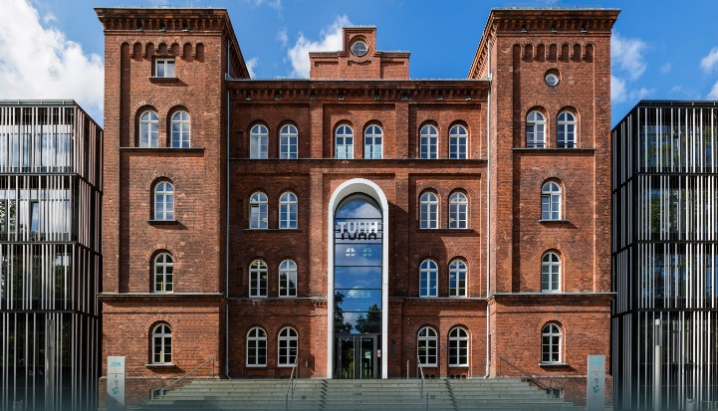

16.-18. September 2020

ONLINE

